**Exercise 1**

1. Install Java SE 8
2. Install Eclipse/IntelliJ IDEA

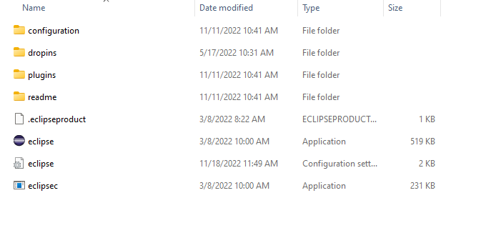

3) Navigate to the folder where Java is installed and study the folder structure

4) Navigate to the folder where eclipse/IntelliJ IDEA is installed and study the folder structure

5) Open command prompt by typing cmd in the Run box

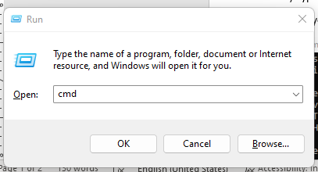

6) Type ‘java -version’ in the command prompt and check if the correct Java version is being

Displayed

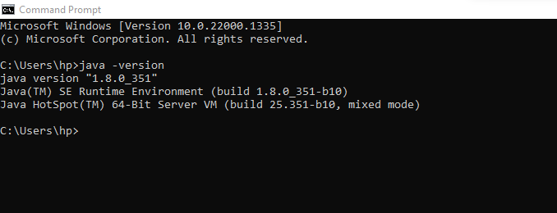

7) Type ‘java’ and see if you are getting the java usage options

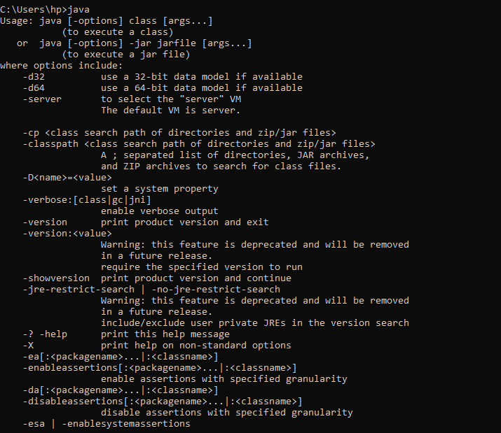

8) Navigate to the Java folder in the command prompt

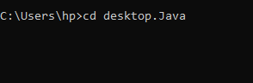

9) Type ‘javac’ and see if you are getting any outputs. If it reports that javac is unrecognized

command, then you need to set the path environment variable to include the java\bin folder

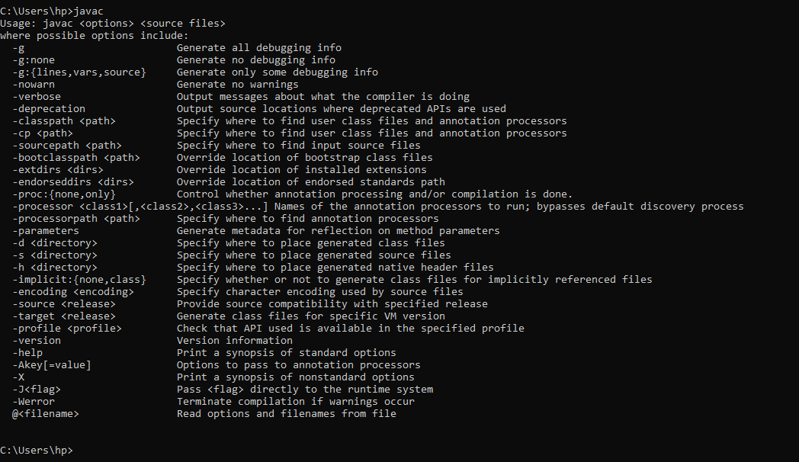

e.g.: set path=%path%; C:\Program Files\Java\jdk1.8.0_291\bin